23.59: a)
b)
c)
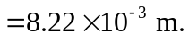
d) Angle
e) The distance below center of the screen is:

